Dr. Roland Weldon
Technology in Motion Specialist
Southeast Alabama Regional Inservice Center
334-268-9035
rlweldon@troy.edu
http://technologyinmotiontroy.weebly.com/

The list provided is a sample of the requested Professional Development sessions that have been delivered at schools in the Southeast Alabama Regional Inservice Center (at the request of LEAs) in the past 12 months. Provided below are 8 defined categories that the ‘Alabama Technology in Motion” have delivered quality on-site Professional Development for educators recently. Please let me know if you have any questions and would like PD training on-site at your school for the 2nd semester of the 2014-15 school year.
Technology in Motion Course Catalog
PD Title Number | PD Title | Credit Hours
TU4094 | IPAD "Out of the Box...and into the Classroom" | 2.5
TU4095 | 11 Teacher Tools For Your Toolbox | 2.5
TU4100 | Google Applications for Educators: Google Email, Calendar, & Drive | 2.5
TU4101 | Current Communication Tools for Elementary Level Educators: Class Dojo & Remind | 2.5
TU4102 | Current Communication Tools for Secondary Level Educators: Remind & Web-Presence | 3
TU4103 | Take It To the Clouds! | 2.5
TU4104 | Edmodo as a Communication Tool for the Classroom Teacher | 2.5
TU4105 | IPAD Integration Strategies: App Smashing | 3
TU4106 | LiveBinders: Digitizing Curriculum for Teachers & Developing Digital Portfolios for Students | 3
TU4107 | Weebly Websites Created Easily...No, Really! (Basics & Adding Digital Content) | 3
TU4108 | Weebly Websites Created Easily...No, Really! Creating MyAcademy | 3
TU4109 | Pinterest as a Bookmarking and Collaborative Tool | 1.5
TU4110 | Interactive Whiteboard Utilization in the Elementary Classroom | 2.5
TU4111 | Interactive Whiteboard Utilization in the Secondary Classroom | 2.5
Dr. Roland “Buddy” Weldon

Overview of Program
- Technology in Motion Orientation
Description/Abstract: This session will highlight the available resources and training that Technology in Motion has to offer that would enhance instruction with Career Technical Education teachers.
Objectives: Participants will be introduced to various resources that Technology in Motion has to offer teachers and leaders across the state. Also, multiple options of how Professional Development is implemented will be demonstrated (face-to-face, online, and blended formats). Participants will be informed concerning the contact person for each region of the state assigned to their area.

Communication Tools
- Communication Tools for the Elementary/Secondary Level Teacher (Remind, Class Dojo, & Voxer).

Description/Abstract: This session covers SymbalooEDU, a Personal Learning Environment (PLE) tool that allows you to organize websites and resources in one place for you and your students. You can create webmixes, which are pages you can create to organize your web content and resources. Each resource is created in the form of a tile, making Symbaloo quick and easy to use. Follow this step-by-step guide to create your own webmix!

Visual Book Marking Program
- Creating Personalized Learning Environments for Educators and Learners!
Description/Abstract: This session covers SymbalooEDU, a Personal Learning Environment (PLE) tool that allows you to organize websites and resources in one place for you and your students. You can create webmixes, which are pages you can create to organize your web content and resources. Each resource is created in the form of a tile, making Symbaloo quick and easy to use. Follow this step-by-step guide to create your own webmix!

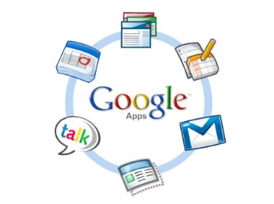

Google Application for Educators (GAFE Training)
- Google This! Tools for Teachers! Series: Google Gmail, Calendar, and Drive.
Description/Abstract: No more outdated calendars! With these Google tools, you can manage multiple calendars and share them with groups of people…individual classes, teams, designated parents, etc. Teachers receive immediate notifications when calendars are changed. Learn to add reminders and never miss an event again!
Objectives: To provide practice and utility for the most popular email type program commonly available. (Gmail). To provide a digital jump drive (copy) of important files in a safe environment (Google Drive). To demonstrate the collaboration and privacy tools in Google Drive. To utilize the Google Calendar (private and collaboratively) on multiple devices.
Cloud-based Storage Application
- Take It 2 the Clouds
Description/Abstract: This 1-HR session covers the popular cloud-based storage tool that allows you to access digital content on any type of device. Also, and outstanding method to instantly upload pictures and videos from mobile devices.
Objectives: Upload complete folders (jump drives) with ease. Integrates with Google Drive & can use interface similar to DropBox. Easy to share and secure files and folders among individuals. Box App on IPAD & IPhone allows for instant upload of videos to account.
- Digitizing Content with Screenshots and Screencasting Tools (Flipping the Classroom Tool!)
Description/Abstract: This 1-HR session covers the best tools to record teacher instruction in various modalities. All content covered is free for the computer user.
Jing (PC & MAC Screencasts) allows for presenter to record voice while navigating Microsoft Office products, websites, and digital content on your computer.
ShowMe/Educreations (Tablet Screencasts) allows for presenter to record voice and write on an interactive whiteboard (with an IPAD). Excellent for lectures (across the curriculum).
Box allows for computer user to store up to 50GB of videos, pictures, documents, and presentations, replacing traditional jump drives. Video creators (via Smartphone or Tablet) allows for teachers to deliver lectures and students can develop projects.

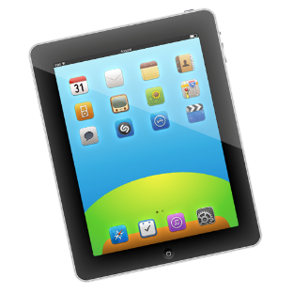

IPAD Tablet Training
Session Title: IPAD Integration Tools and Apps
Description/Abstract: This 1-HR session covers IPAD basics (settings), basic hardware components, and simple navigation and management practices with this popular tablet device.
Objectives: Familiar teachers with the Apple ID/Store. Review Settings, Safari Browser, and Email Account accessibility. Connectivity tools (Apple TV, AirServer, and Reflector App)
Effective Use of Current Learning Management Systems
Session Title: Edmodo N A Day
Description/Abstract: Creating Accounts/User Interface, Adding Digitized Curriculum/Content (Assignments & Resources, Grades, & Calendars), and Adding Enhancements (Practice/Create Your Edmodo Class). Finally! An easy way for teachers to develop and deliver rich content in an interactive format. The popular Edmodo (Integration) App Blendspace is also featured.
Session Title: Google Classroom for the 21st Century Teacher (Coming Soon!)
Description/Abstract: Utilize this new LMS format for classroom learning. A great option for school that have already adopted Google as their vehicle for communication!. These within the LMS, and best practices for teachers to use this exciting new tool for teachers (specific for grade level and subject areas taught).
Web-based Classroom Content/Delivery Systems
Session Title: Flipping the Classroom & Incorporating Project–Based Learning Opportunities
Description/Abstract: This session focuses on alternative web-presence for educators (and students) to use to house and deliver teacher products, instructional and curriculum resources [Weebly/Remind] as well as student developed digital products [Livebinders]. This is a 3- Hour session or 3 1-hr segments:
- Creating an effective Web-presence
- Delivering content and instruction effectively
- Developing digital Projects –based learning with Livebinders

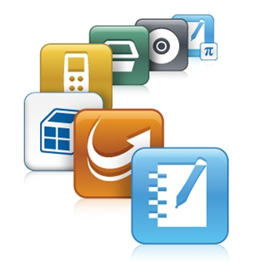

Interactive Whiteboard Content
Session Title: Interactive Whiteboard Utilization in the Elementary/Secondary Level Classroom
Description/Abstract: These 3 sessions focus on 3 concentrations:
Beginner Introduction for teachers with no or limited experience in using Interactive Whiteboards. An overview of the IWB software program (ActivInspire, Notebook, etc) is covered.
Intermediate focuses on utilizing web-based content and enhancing curriculum and instructional methods in the classroom to improve student learning opportunities.
Update Training is for educators that use newer versions of existing IWB software programs and need training on the new changes and practical utility of the program (Notebook 14 for the 2014-15 teacher)

